**Application Layout design**: Being an information systems major, I drew diagrams to help the computer science major team paint a picture of how the application needed to be programmed. The images below are examples of the rough visual outline drawn.

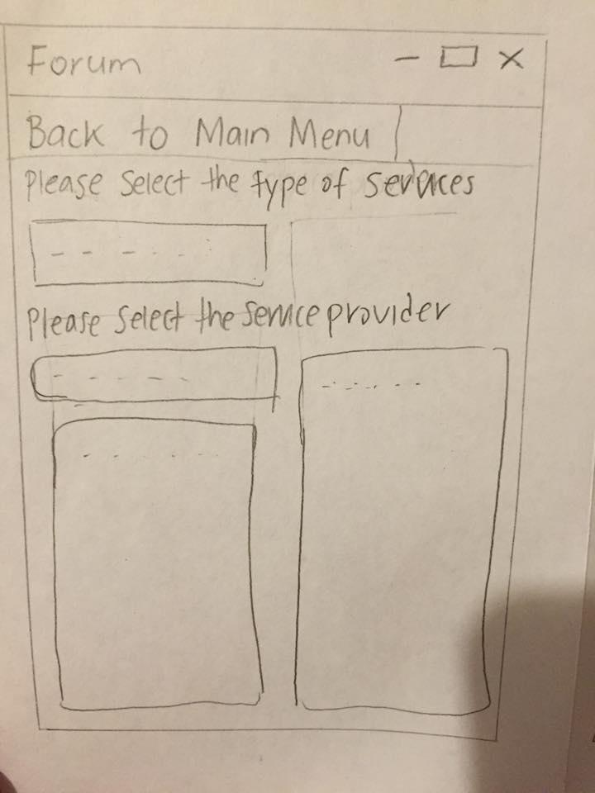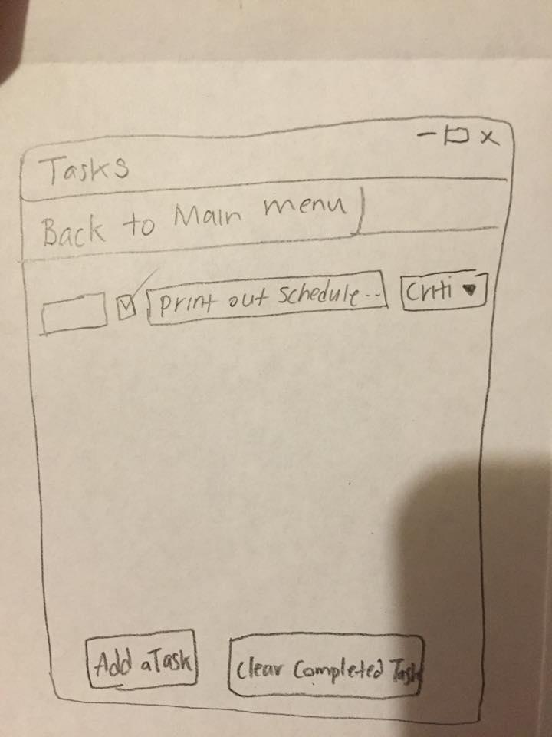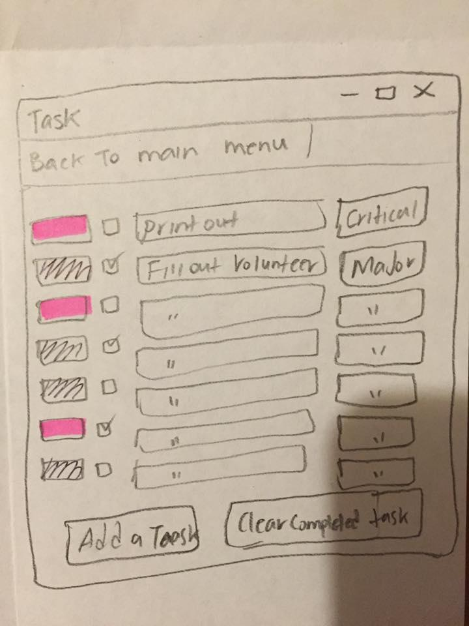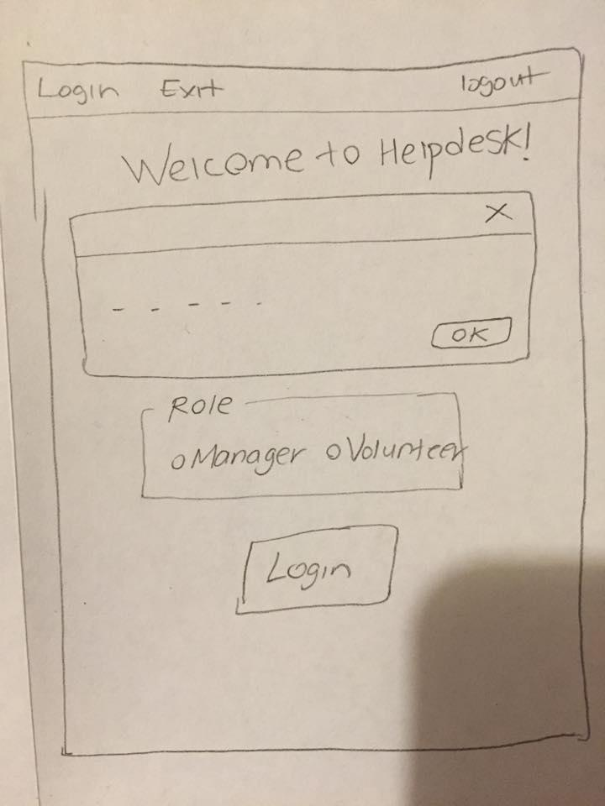

**Programming**: Though most of the coding was done by the computer science major team, I contributed with one of the important sections. My contribution can be viewed here:

<https://github.com/MrMagic9/IFB299---The-cavalry---Help-Desk/blob/master/Helpdesk/main_form.cs>

**Acceptance test**: This test was was performed to check whether or not the user story meets its ultimate goal. This test does not require the person being tested to have prior knowledge about how the application works.

**Feedback**: Feedback came from friends and family who did not know how to use the application so that their response is more transparent. The feedback received included thoughts and opinions about the application’s usefulness, attractiveness, user friendliness and visibility. All feedback was usefull in the tweaking and improvement of the application.

**Client & development team liaison**: I attempted to uphold strong communication channels in and out of workshops with the development team so that both sides have full awareness of the application’s development progress. My efforts also aimed to promote understanding and efficiency.